**OSH Authorities – Estonia**

Source: <https://oshwiki.eu/wiki/OSH_system_at_national_level_–_Estonia>

* OSH Infrastructure

Scheme:

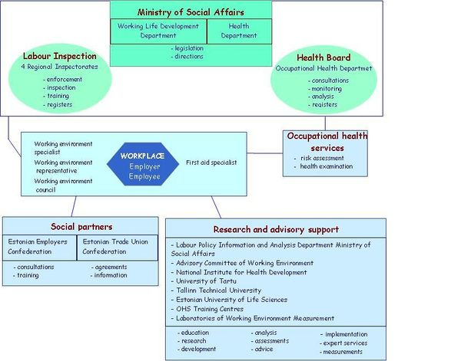

* OSH Authorities

|  |  |
| --- | --- |
| Name of the Authority | Ministry of Social Affairs (Sotsiaalministeerium) |
| Link | <http://www.sm.ee/et> |
| Short abstract | In the Estonian occupational health and safety system, the Ministry of Social Affairs is the executive authority which regulates the entire field, whereas two of its structural units (the Working Life Development Department, and the Health Department) are directly involved in occupational health and safety-related policy-making.  The Working Life Development Department is responsible for the overall co-ordination and management of the activities in the field of occupational health and safety. The Working Life Development Department:   * Plans and implements the working environment policy; * Elaborates regulations on occupational health and safety. |
| Link to OSH wiki | <https://oshwiki.eu/wiki/OSH_system_at_national_level_–_Estonia> |

|  |  |
| --- | --- |
| Name of the Authority | Health Board (Terviseamet) |
| Link | <http://www.terviseamet.ee/en/information/about-hb.html> |
| Short abstract | Three Estonian governmental health authorities - Health Protection Inspectorate, Health Care Board and Chemicals Notification Centre are unified in the joint Health Boardin 2010.  In the field of occupational health the Health Board's role is to:   * Participate in the preparation of occupational health programmes and organize their implementation; * Analyze information concerning occupational illnesses and illness related to the work of *Organize refresher courses for occupational health specialists; * Register occupational health service providers. |
| Link to OSH wiki | <https://oshwiki.eu/wiki/OSH_system_at_national_level_–_Estonia> |

|  |  |
| --- | --- |
| Name of the Authority | The Labour Inspectorate (Tööinspektsioon) |
| Link | <http://www.ti.ee/index.php?page=3&> |
| Short abstract | The Labour Inspectorateis a government agency operating under the jurisdiction of the Ministry of Social Affairs, and its main functions are to:   * Arrange for the exercise of state supervision in the working environment with respect to compliance with the requirements of legislation regulating occupational health and safety and labour relations and to apply enforcement by the state on the bases and to the extent prescribed by law; * Exercise market supervision over safety of the personal protective equipment in the use in the working environment and to ensure the protective properties of the equipment at sites of manufacturing and sale; * Exercise supervision over investigations into occupational accidents and diseases and over the implementation of measures for the prevention of occupational accidents and diseases; * Investigate fatal and if there is a need, then conduct an analysis of the causes of serious occupational accidents and diseases and analyze their causes; * Collect statistics of accidents at work and conduct analysis thereof; * Exercise supervision over the use of genetically modified micro-organisms in closed environments to the extent prescribed by law; * Take decisions in cases prescribed by law on issuing or withholding approval; * Carry out administrative proceedings; approve administrative acts and rules; * Carry out extrajudicial proceeding of misdemeanours to the extent prescribed by law; * Initiate criminal proceedings and carry out urgent investigative actions; * Carry out and resolve petitions from individuals on working environment issues; * Resolve individual labour disputes pursuant to the procedures prescribed by law. |
| Link to OSH wiki | <https://oshwiki.eu/wiki/OSH_system_at_national_level_–_Estonia> |

* Compensation and insurance bodies

|  |  |
| --- | --- |
| Name of the Body | The Estonian Health Insurance Fund (Eesti haigekassa) |
| Link | <http://www.haigekassa.ee/en> |
| Short abstract | The basic principle followed in Estonia is that there is no specific insurance against employment injuries and occupational diseases. These risks are covered by the health insurance (short-term benefits) and pension insurance (long-term benefits). Under the employer's civil liability, additional benefits can be provided as compensation. All employees are the beneficiaries of the system.  Estonia has no formal system of state insurance for occupational accidents and diseases even though there has been significant developments and improvements of occupational health and safety legislation has taken place in the past few years. |
| Link to OSH wiki | <https://oshwiki.eu/wiki/OSH_system_at_national_level_–_Estonia> |

* Research Institutes

|  |  |
| --- | --- |
| Name of the Institute | National Institute for Health Development (Tervise Arengu Instituut) |
| Link | <http://www.tai.ee/en/> |
| Short abstract | The National Institute for Health Development (Tervise Arengu Instituut; NIHD)was established in 2003 as a governmental organization under the Ministry of Social Affairs of Estonia. The mission of NIHD is to promote the health of the Estonian population and enhance the quality of life through knowledge-based development and applied research activities. The main activities of the NIHD are research, development and implementation of activities in the health and social sectors. |
| Link to OSH wiki | <https://oshwiki.eu/wiki/OSH_system_at_national_level_–_Estonia> |

|  |  |
| --- | --- |
| Name of the Institute | Tartu University (Tartu Ülikool) |
| Link | <http://www.ut.ee/en> |
| Short abstract | **Tartu University (Tartu Ülikool)**has the following functions relating to occupational safety and health:   * Coordination of the occupational health (OH) teaching programme in the Faculty of Medicine (specialist training for physicians); * Organisation of OHS and surveillance of the working environment in the university and connected units (Biomedicum, Clinicum, ect.); * Leading of OH curricula development in the Department of Public Health; * Organisation and participation in the training courses of OH for other institutions and specialist groups; * Advisory role of OH expertise and programme development in the Ministry of Social Affairs |
| Link to OSH wiki | <https://oshwiki.eu/wiki/OSH_system_at_national_level_–_Estonia> |

|  |  |
| --- | --- |
| Name of the Institute | Tallinn University of Technology (Tallinna Tehnikaülikool) |
| Link | <http://www.ttu.ee/> |
| Short abstract | Tallinn University of Technology (Tallinna Tehn ikaülikool)undertakes basic research and development activity including among others basic research in order to endow the Estonian working environment with high level of safety, quality and productivity. |
| Link to OSH wiki | <https://oshwiki.eu/wiki/OSH_system_at_national_level_–_Estonia> |

* Prevention institutes

|  |  |
| --- | --- |
| Name of the Authority | NONE |
| Link |  |
| Short abstract | In Estonia, there are no prevention institutes as unlike the situation in some European countries. However, preventive activities are included and implemented, in the work of the Ministry of Social Affairs and the Labour Inspectorate most commonly through awareness raising campaigns. |
| Link to OSH wiki | <https://oshwiki.eu/wiki/OSH_system_at_national_level_–_Estonia> |

* Other OSH services

|  |  |
| --- | --- |
| Name of the Society | Estonian Society of Occupational Health Physicians (Eesti töötervishoiuarstide selts) |
| Link | <http://ettas.ee/> |
| Short abstract | The Society was established in the 1990s. Its main activities are to provide additional training to occupational health physicians on current OSH topics, and to arrange workshops and seminars with other specialists, such as family doctors. In addition, the Society works with the Ministry of Social Affairs and the Labour Inspectorate on renewing OSH legislation, and it certifies the Estonian Occupational Health Physicians (the 5 year specialist training is provided by Tartu University and Tallinn Technical University). |
| Link to OSH wiki | <https://oshwiki.eu/wiki/OSH_system_at_national_level_–_Estonia> |

* Standardization Bodies

|  |  |
| --- | --- |
| Name of the Body | Estonian Centre for Standardization (EVS) (Eesti standardikeskus) |
| Link | <http://www.evs.ee/Esileht/tabid/111/language/en-US/Default.aspx> |
| Short abstract | The Estonian Centre for Standardization (EVS)is a non-profit association, which was established by three founding members (Republic of Estonia, Chamber of Commerce and Industry, Confederation of Employers and Industry) in 1999. The Estonian Centre for Standardization operates as the Estonian standard organization pursuant to the Technical Regulations and Standards Act. EVS has accepted the WTO Code of Good Practice for the Preparation, Adoption and Application of Standards for the removal of technical barriers to trade. |
| Link to OSH wiki | <https://oshwiki.eu/wiki/OSH_system_at_national_level_–_Estonia> |